Press Release for Immediate Use

HAVISHAM
World PREMIERE

Written and Performed by Heather Alexander
Direction & Dramaturg by Dominique Gerrard

A journey into the psyche of Miss Havisham from Great Expectations

“Gorgeous Writing…” ★★★★ Paul Vale The Stage (Edinburgh 2023)

‘Powerful, tense, heart-breaking.’★★★★★ 5 star Broadway Baby

The Bridge House Theatre
Bridge House, 2 High St, London SE20 8RZ
21ST & 22nd September
https://www.ticketsource.co.uk/the-bridge-house-theatre/e-yxlyar

Upstairs at The Gatehouse, Highgate, London
16th-19th November 2023
https://upstairsatthegatehouse.ticketsolve.com/ticketbooth/shows/1173647509
SOLO Show. 70 mins

AWARD WINNER of BEST FEMALE ACTOR AT BUXTON FRINGE 2023!

‘If you knew my story, your heart would break too. A cobwebbed tale of heartbreak’

This is the story that Dickens left out….

Who was the woman being behind Dickens’ most monstrous female creation? What drove the hopeful young Miss Havisham to her cruel and fractured fate? Experience her heartbreak as we delve into her childhood trauma and follow her on an intricate journey to a world where she finds herself ‘the leading lady in a drama she can’t comprehend.’ The gaslighting is subtle, the coercive control slick. Can Miss Havisham escape her twisted karma? Or is she destined to impose the devastation of her trauma on a new victim?

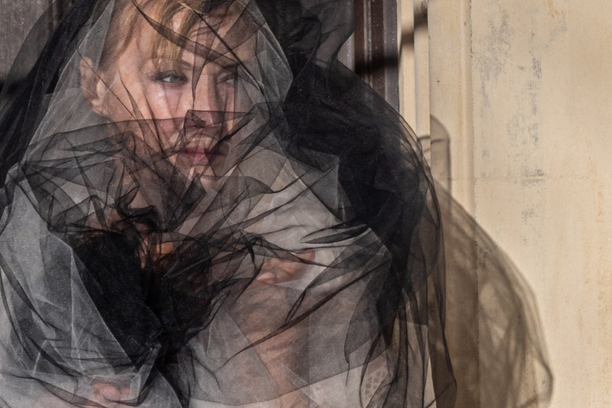

Heather Alexander is an award-winning actress and writer with a prodigious list of stage, television, and film credits. Recently she has been performing ROOM (an adaption of Woolf’s A Room of One’s Own) and Shirley Valentine to packed houses.

Dominique Gerrard – a dramaturg and director working largely with writers on developing new plays. Recent credits include award winning production Quintessence (Emily Carding), SOE & A Necessary Woman (both for Clair Obscur Theatre) and Heather's previous work Room (Emul8). She runs Hastings Meisner and Vital Theatre.

Emul8 Theatre Company challenges boundaries, seeking to engage the audience in a dialogue around themes of justice, female empowerment, and freedom of expression. We develop fresh ideas and perspectives, offering new writing around current issues, concerns and controversies. We also dramatise and adapt existing iconic texts, making them accessible and relevant to a contemporary audience. Emul8 seeks to interrogate prejudices and stereotypical representations through thought-provoking and innovative text and staging.

REVIEWS

5 Star BROADWAY BABY ★★★★★

‘Powerful, tense, heart-breaking.’

https://broadwaybaby.com/shows/havisham/794532#:~:text='%20The%20gaslighting%20is%20subtle%2C%20the,Great%20Expectations%20by%20Charles%20Dic

4 Star THE STAGE Paul Vale ★★★★

“gorgeously written and packed with haunting imagery”

https://www.thestage.co.uk/reviews/havisham-review-zoo-playground-edinburgh-heather-alexander

5 Star WEBF ★★★★★

“This is a beautifully crafted piece of theatre, whether you are a fan of Dickens or not. The story stands strong alone.”

“a cobwebbed tale of heartbreak”

https://www.westendbestfriend.co.uk/news/fringe-review-havisham-emul8-productions

4 Star Theatre Weekly ★★★★

“Havisham stands out for its original and skillful narrative craft, as if characters and atmospheres were drawn from the pages of a literary piece, while simultaneously, opening a poignant contemplation on the power of trauma over the psyche and body of its sufferers.”

https://theatreweekly.com/edinburgh-review-havisham-at-zoo-playground/

FRINGE REVIEW – Hidden Gem

‘As ever with Alexander, this is a masterclass in acting.’

http://fringereview.co.uk/review/brighton-fringe/2023/havisham/

Reviews continued

4 Star Theatre Film and Arts Reviews ★★★★

‘Intriguing…the story intertwines smoothly…’

‘Alexander seems to unlock her own demons in Havisham, as well as her own angelic side and is a breathtaking sight to behold on stage.
‘Powerful, tense, heartbreaking.’
★★★★★ 5 star Broadway Baby
https://broadwaybaby.com/shows/havisham/794532

‘As ever with Alexander, this is a masterclass in acting. The OUTSTANDING one-person show of the Fringe so far.’

http://fringereview.co.uk/review/brighton-fringe/2023/havisham/

Praise For Room – A Room of One’s Own (Emul8 2022)
'An exquisite performance…as a condensation and enactment of Woolf's seminal text, this can't be improved.'
OUTSTANDING - FringeReview

'Alexander, as Room's writer, delivers a linguistic treat. The language is a joy to hear. As a performer, Alexander is a delight to watch. Her assured performance is pitch perfect, and her nuanced vocal delivery brings the rich language to life.'
★★★★★ Reviews Hub

'Heather Alexander lit up the stage as she portrayed one of the most fearless female writers in history.'
★★★★ Broadway Baby

‘A beautiful portrayal by an accomplished actor at the top of her game.’
★★★★ British Theatre Guide

'Heather Alexander has invented a new genre and format.'
CNS Theatre

Dates

The Bridge House Theatre
Bridge House, 2 High St, London SE20 8RZ
21ST & 22nd September
https://www.ticketsource.co.uk/the-bridge-house-theatre/e-yxlyar

Upstairs at The Gatehouse, Highgate, London
16t^{h}-19th November 2023
https://upstairsatthegatehouse.ticketsolve.com/ticketbooth/shows/1173647509

Press Contact: Heather Alexander : emul8theatre@gmail.com : 07970 820 372
BOOKINGS: emul8theatre@gmail.com
Website: http: http://www.heatheralexandershows.co.uk/havisham
Twitter: @HAlexTheatre Facebook: heather.alexander.1485
Instagram: heatheralexandertheatre

